**DocCure**

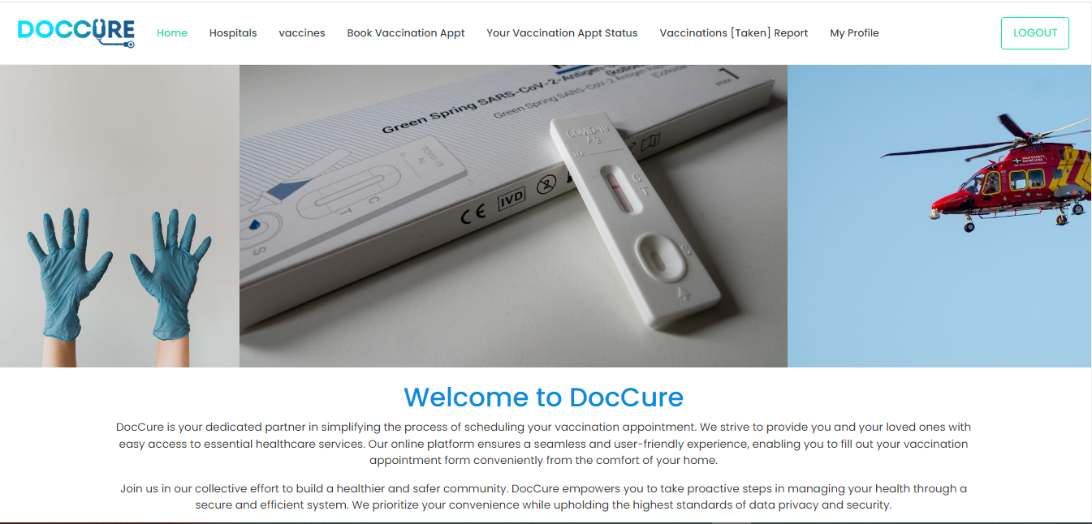

**VACCINATION SYSTEM**

**PROJECT GROUP MEMBER**

|  |  |
| --- | --- |
| **Students Id** | **Students Name** |
| ***Student 1449717*** | ***Muhammad Mohsin Mukhtiar*** |
| ***Student 1444862*** | ***Fareeha Parwaiz*** |
| ***Student 1429148*** | ***Marfia Rani*** |
| ***Student 1449388*** | ***Muhammd Ahsan*** |

**CURRICULUM BATCH**

**7062 2301B2**

**FACULTY**

**SIR HARIS NASSER**

**CO-ORDINATOR**

**MISS MAHA HAIDER**

**CERTIFICATE**

This is to certify that the dissertation entitled

**“DOCCURE CHILDVACCINATION SYSTEM”**

IS **MUHAMMAD MOHSIN MUKHTIAR**

**STUDENT1449717, FAREEHA PARWAIZ**

**STUDENT 1444862, MARFIA RANI**

**STUDENT 1429148, MUHAMMAD AHSAN**

**STUDENT 1449388,** in their partial

fulfilment of the requirement of the award

of the Aptech Computer Certified.

**ADMIN PANEL:**

**ADMIN LOGIN**

Here You can Login in Your Admin Account.

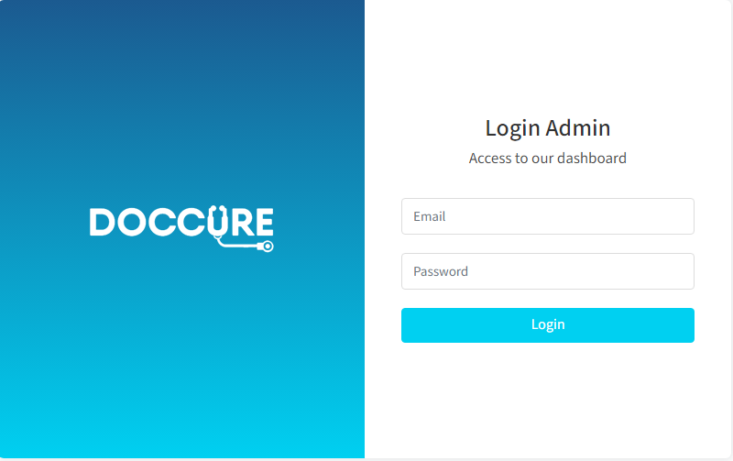

**HOME:**

Admin can read the details of login users.

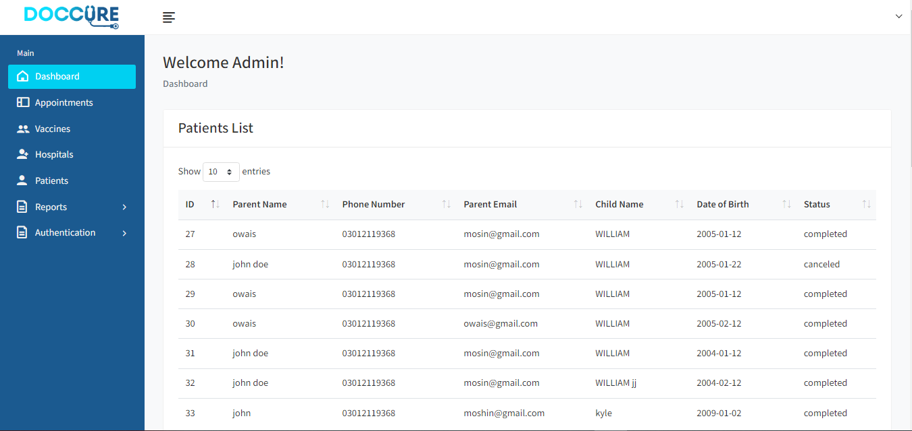

**PATIENTS:**

This is a patient list. where you can saw all patient

details..



**VACCINE:**

Vaccine list are available here.

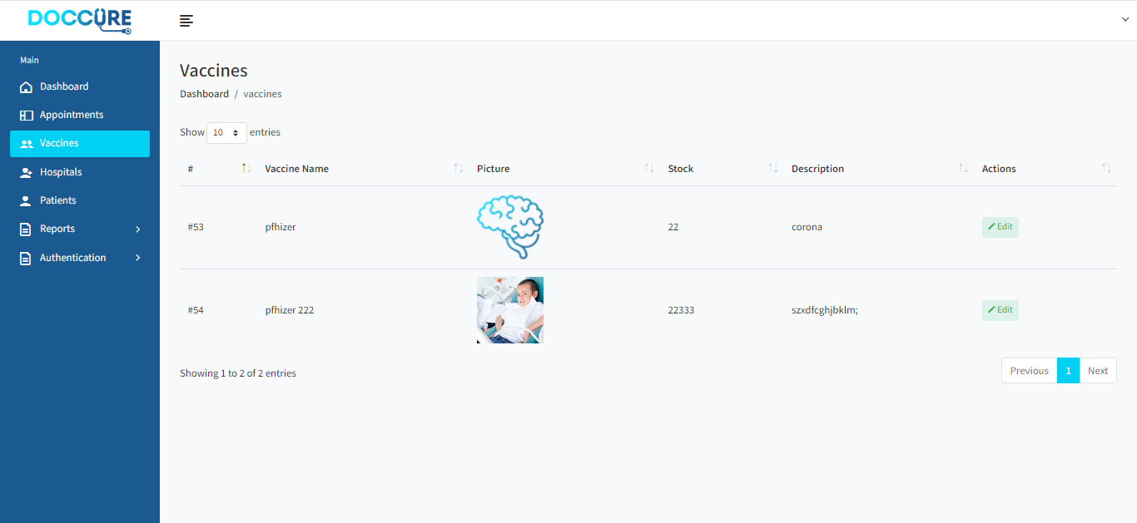

**VACCINATION REPORTS:**

**VACCINATION REPORTS:List.**

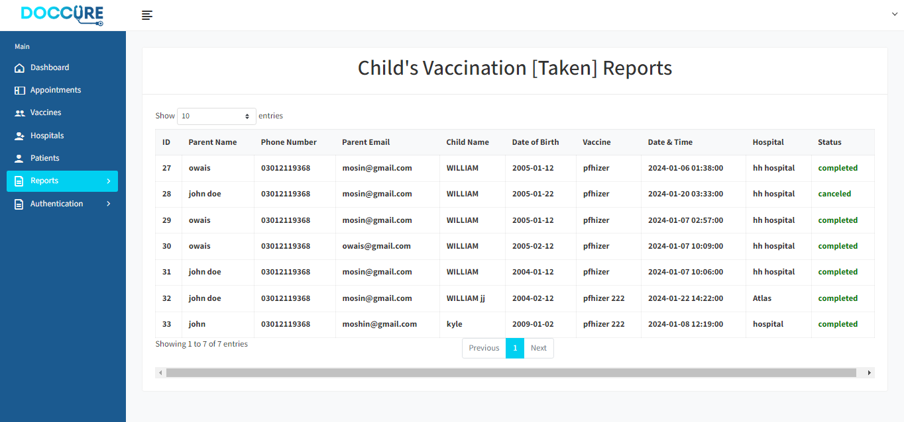

**APPOINTMENT:**

Appointment list you can easily saw there & take actions

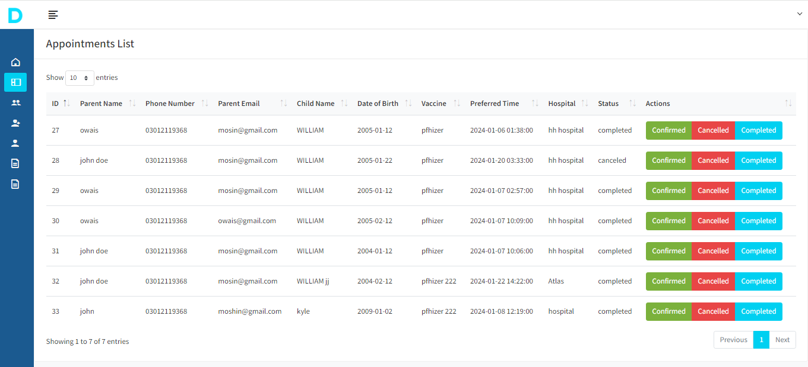

**HOSPITALS:**

Hospital list you can easily saw there & add,edit or delete.

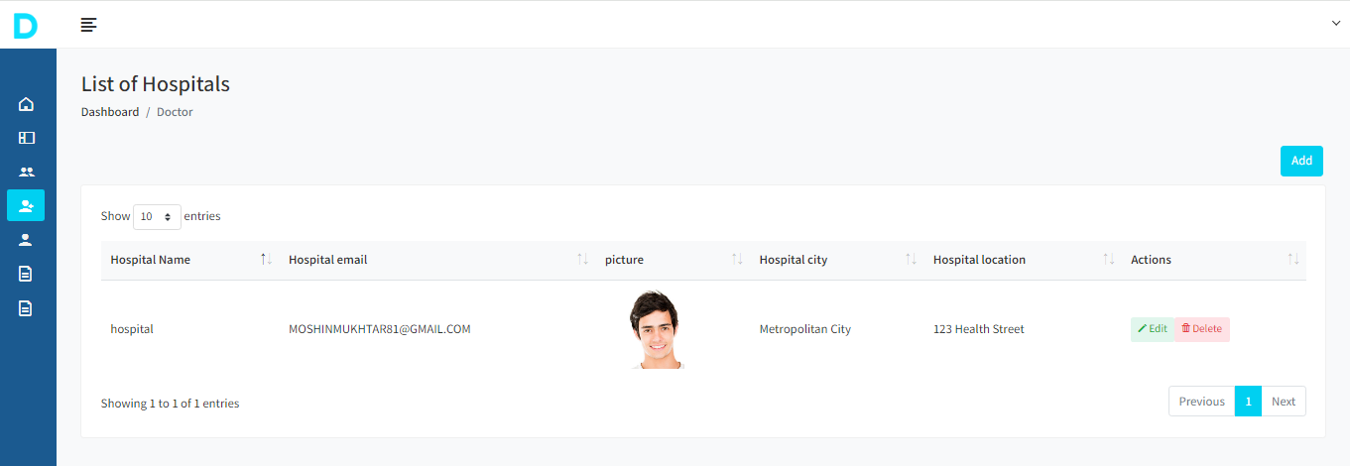

**ADMINHEADER/SIDEBAR:**

Here you can saw you’re all details related admin panel.

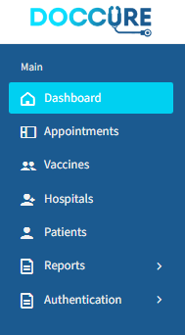

**HOSPITAL PANEL:**

**HOSPITAL REGISTER PANEL:**

Here is a Register page of hospital. Hospital can easily Register your account

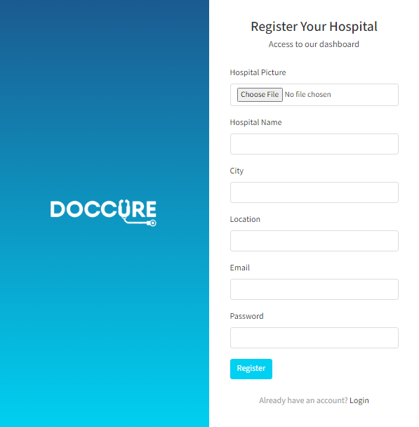

**HOSPITAL LOGIN PANEL:**

Here is a Login page of hospital. Hospital can easily

Login your account

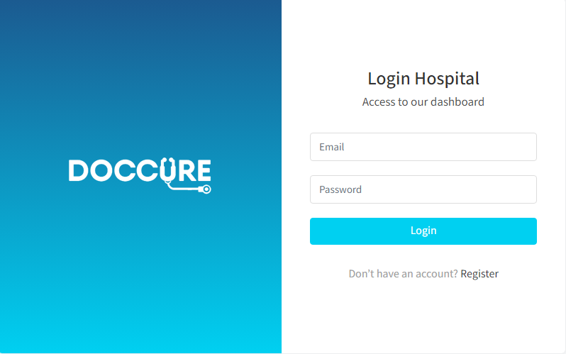

**HOSPITAL DASHBOARD:**

Here is a dashboard where can saw all hospital data

easily.

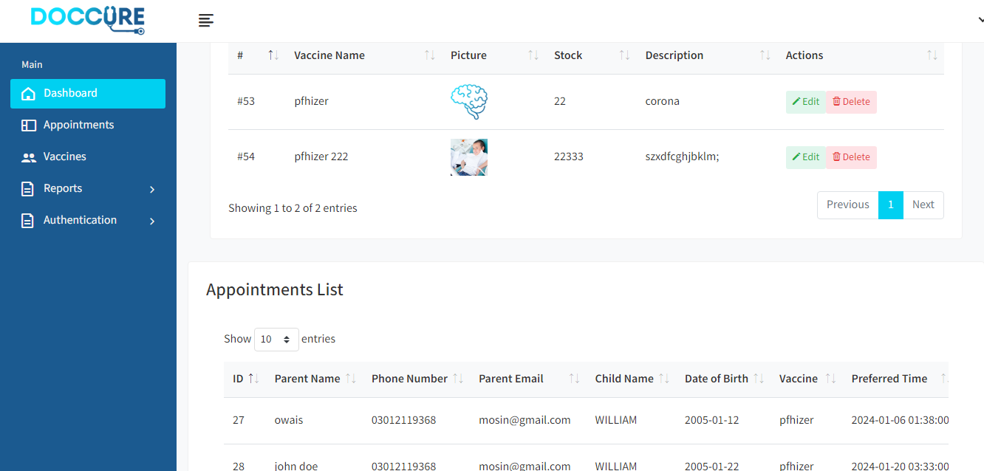

**APPOINTMENTS LIST:**

Appointment list see in this picture.

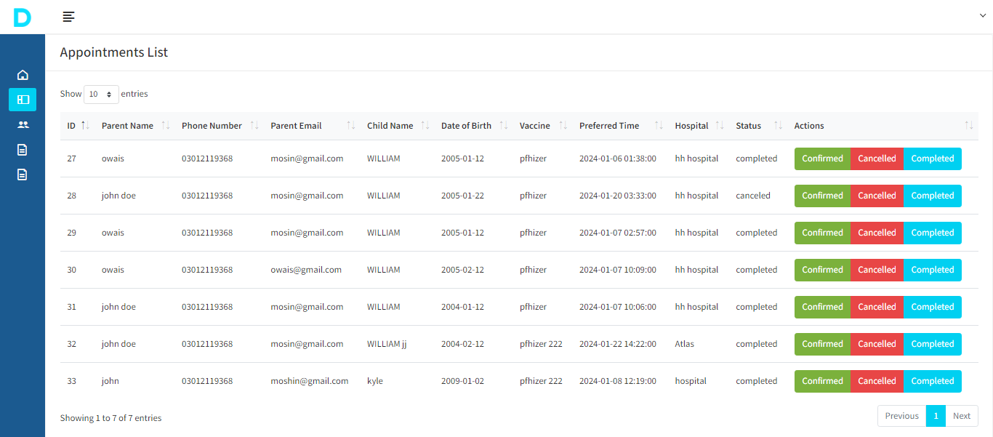

**VACCINATION REPORT:**

All vaccination reports list are here.

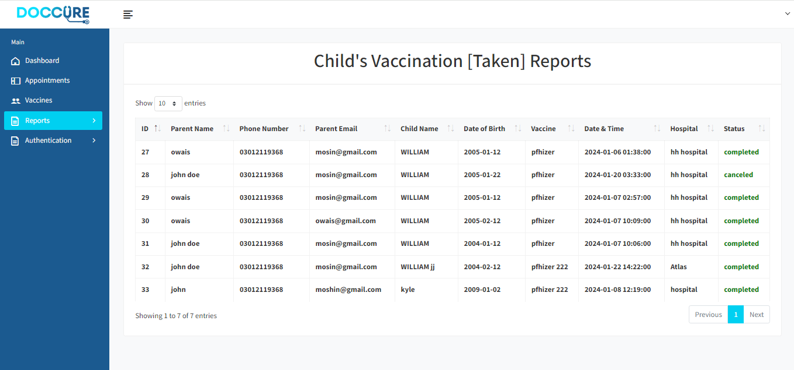

**PATIENT:**

**PATIENT LOGIN:**

Here is a Login page of patient , Patient can easily login

there Account.

STEP 1



STEP 2

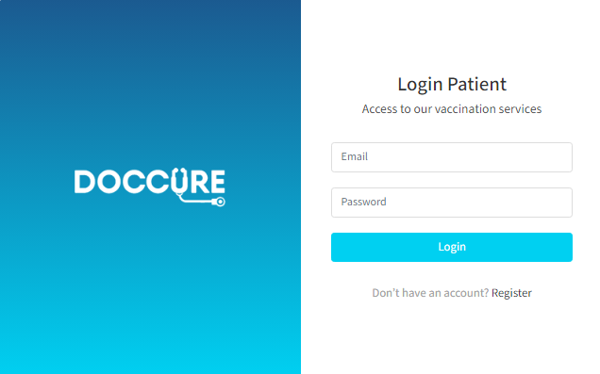

**PATIENT REGISTER:**

Here is a Register page of patient , Patient can easily

Register there Account.

STEP 1



STEP 2

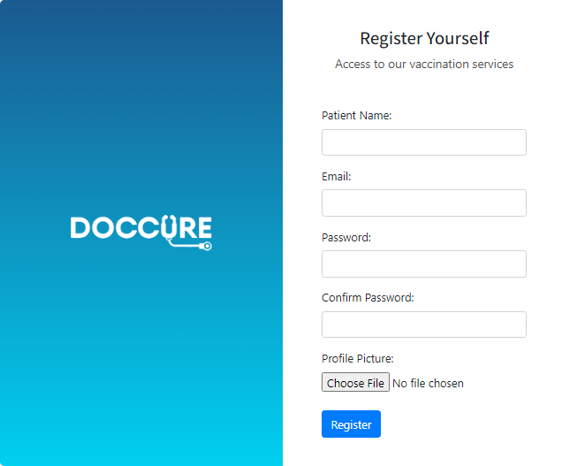

**HOME:**

Here a Home Page.

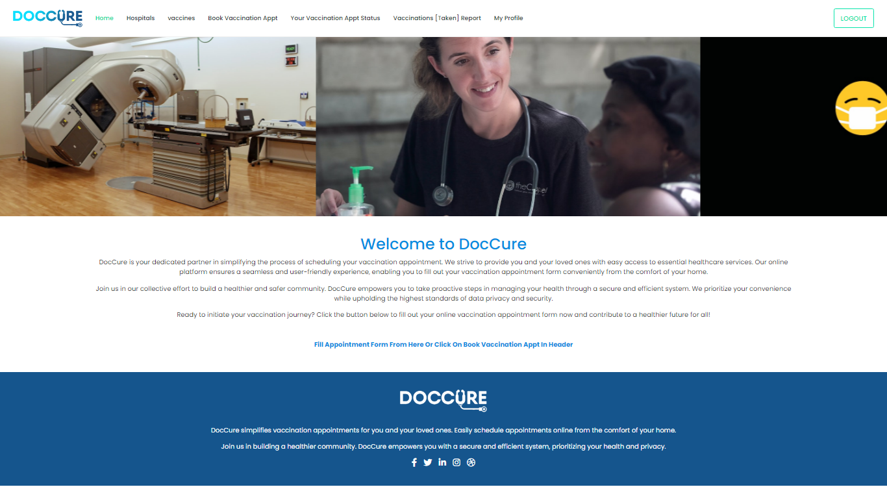

**ABOUT :**



**HEADER:**

Here is header.



**FOOTER:**

Here is Footer.

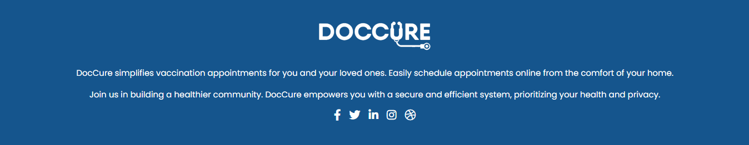

**VACCINATION APPT:**

Here You book you’re vaccination appt by easily

Over there.

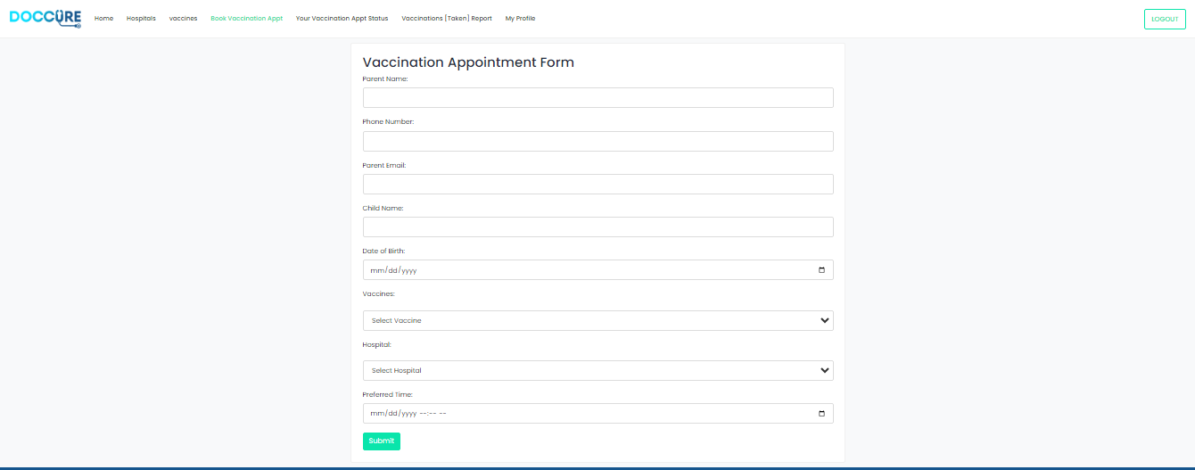

**VACCINATION APPT STSTUS VIEW:**

This is a place where you would saw updated status

Of your vaccination appt form.

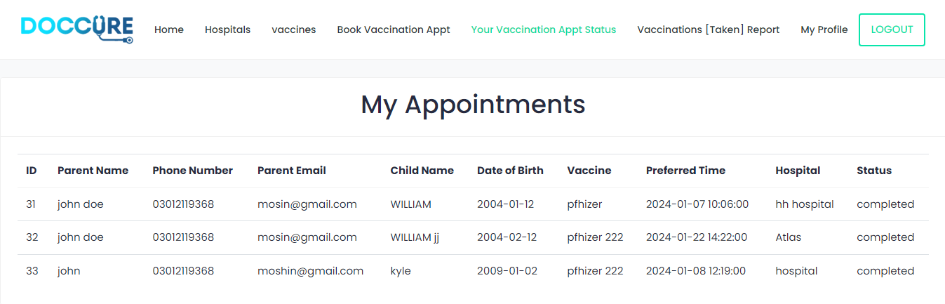

**VACCINATION [TAKEN]**

**REPORTS VIEW:**

Vaccination reports are here.

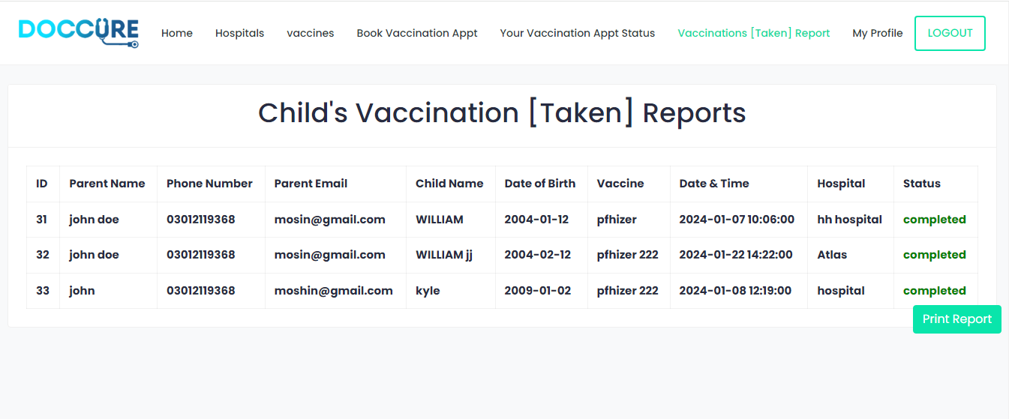

**HOSPITAL:**

Here is a Hospital Page Where we can saw all Hospital.

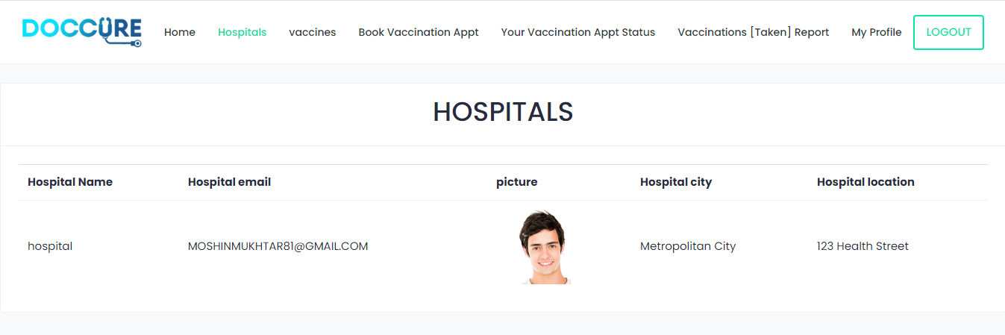

**VACCINES:**

Vaccines list are here.

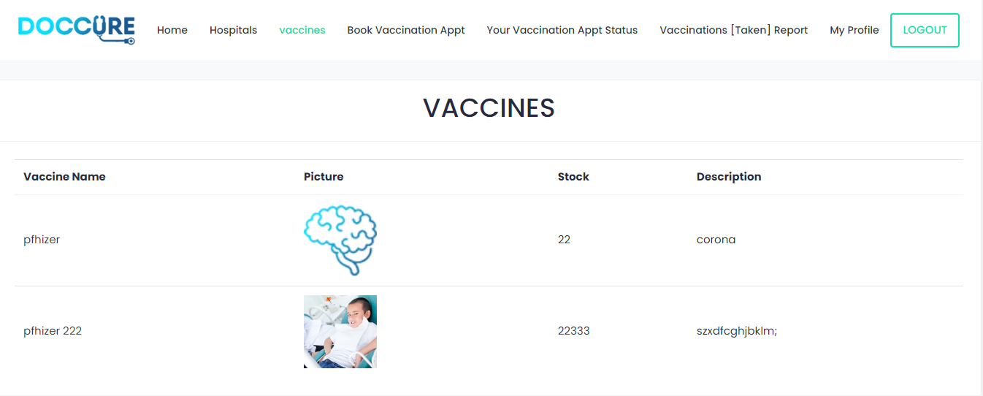

**PROFILE:**

User Profile data are as follow in this picture.

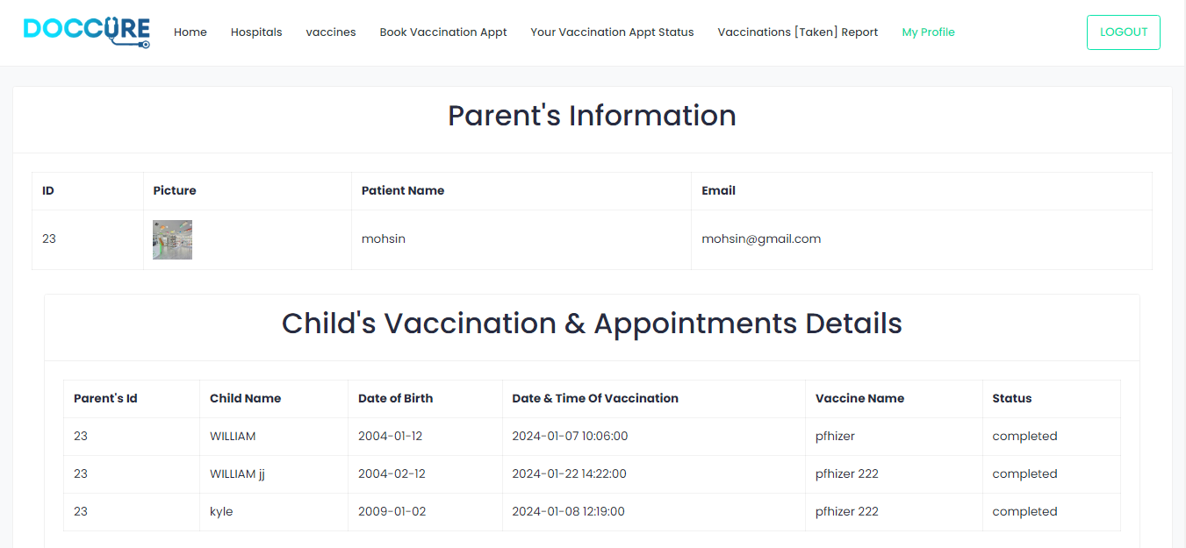

**CONTACT US:**

Here you can contact it and tell us about you’re details

and send us suggestion too

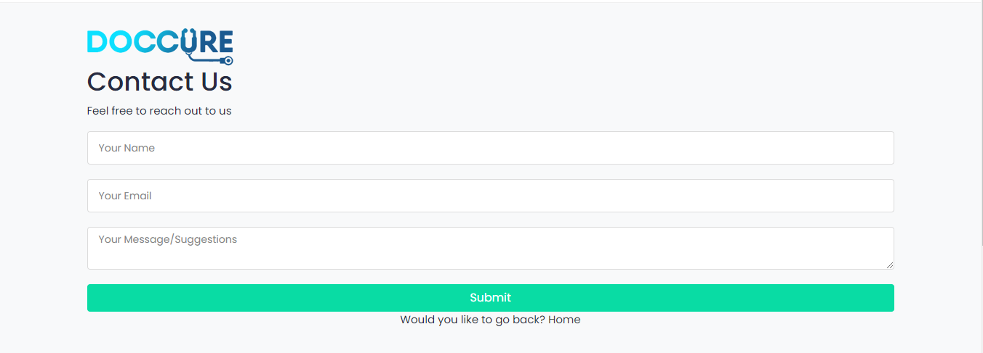

**DocCure!**

